10:47 ‎21/‎03/‎2012 The Mail Body:

From: Natan Osnis [mailto:natan_osnis@bezeqint.net]

Sent: Saturday, March 17, 2012 1:07 PM

To: Avi Keren; Yossi Sarusi; Tal Berger; 'Igor Natachanny'

Subject: Phantom board debugging.

Hi All,

1. **STM3220G-EVAL board:**

1.1. For working in RMII mode, when clock is provided by external oscillator U3,

JP5 must not be fitted, resistor R212 has to be removed and SB1 closed.

1.2. 50MHz external clock not work (U3).

**2. Phantom:**

2.1. Electronic board executes the entire cycle of initialization, comes in the "Task manager" and is idle.

2.2. In an attempt to establish an Internet connection, your PC displays the message “Hardware error.”

2.3. The reason and what should be done are set out in the attached document.

3. Let me know if you want, so I continued to work.

Best Regards

Natan Osnis

Phone/Fax: 04-624-7576

Mobile: 054-4523-881

E-mail: [Natan_Osnis@bezeqint.net](mailto:Natan_Osnis@bezeqint.net)

The pin out of connector J14 does not match the connector J00-0065NL.

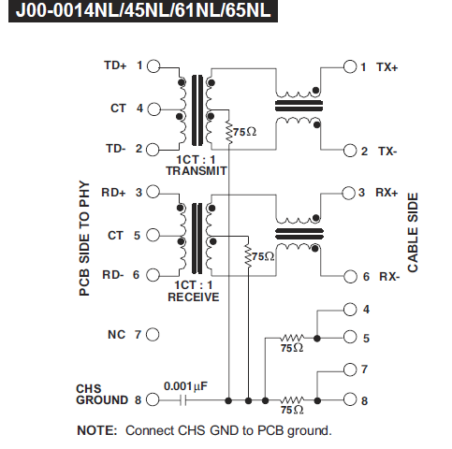

1. Wiring diagram of connector should be as follows:

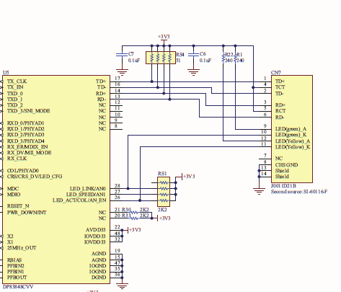

1. Since the connector has a transformer to correct the discrepancy by changing the cable is not possible.
2. In the board must make the following changes:
   1. Signals TCT and RCT:
      1. Connect J14/4 – J14/5 – 3V3
      2. Solder 2 additional capacitors = 0.1 mF (optional).
   2. Signal RD+ :
      1. Solder resistor R54 = 49.9 Ohm.
      2. Remove C77 (optional replace to cap. = 10pF).
      3. Remove R57.
      4. Connect J14/7 and J14/3.
   3. Signal RD- :
      1. Solder resistor R53 = 49.9 Ohm.
      2. Remove C76 (optional replace to cap. = 10pF).
      3. Disconnect U10/13 from via in PCB.
      4. Connect J14/6 and U10/13.